PHYSICS 202
SPRING 07
LAB 5

Part 1. Measuring the resistance of a diode in both directions.

In a resistor both terminals are equivalent, thus, it doesn’t matter if the resistor leads are switched, the resistor still has exactly the same effect on the circuit. In a diode, the terminals are distinct. One is referred to as the anode and the other as the cathode. In one convention, a colored band identifies the cathode. Using the (real) Simpson multimeter as an ohmmeter measure the resistance of the resistor and the two diodes. You should measure the resistance twice, once with the red lead on the anode side and once with the black lead on anode side. (For the resistor, use the tolerance band to indicate which direction you are measuring.) Enter the values you observe below.

 | Measured resistance  Red lead on anode |  | Measured resistance  Black lead on anode
 | 20-kΩ Setting | 200-kΩ Setting | 20-kΩ Setting | 200-kΩ Setting
Black with gray band
Cooper with black band
Resistor

Part 2. IV curve of a diode using Electronics Workbench.

Using Electronics Workbench Multisim, construct the circuit below.

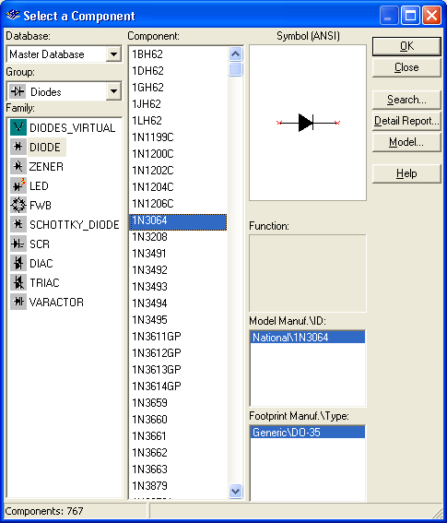

Note that a diode (found under the diode button, next to the basic (resistor) button) is represented as an arrow and a vertical line. Choose the 1N3064 diode. The arrow is on the anode side, and the cathode is on the vertical line side. Set the internal voltmeter resistance to 1000 MΩ and the internal resistance of the ammeter to 1 nΩ, so that the meters are very nearly ideal. Vary the battery voltage from 0.0 t0 1.0V, and record the voltage across the diode and the current through the diode. Then use Excel to plot the current through the diode versus the voltage across the diode. Paste it into your report.

Voltage across battery | Voltage across diode  (in V) | Current through diode  (in mA)
0.0
0.1
0.2
0.3
0.4
0.5
0.6
0.7
0.8
0.9
1.0

Be sure that you convert all voltages to volts and all currents to milliamps. Recall that the resistance is the ratio of Voltage to Current. If the graph of Current versus Voltage is a straight line (as it was for the resistor), then the ratio (resistance) is constant. Such a device is said to be linear or Ohmic. The graph of Current versus Voltage for the diode is not a straight line, and thus we say that the diode is a nonlinear or “non-Ohmic” device. Make a plot of resistance versus voltage. Paste it into your report. (You have to exclude voltages for which the current is zero and perhaps even the first couple voltages with non-zero currents.) Calculate the resistance for a low voltage and a high voltage.

 | Voltage used  ( ) | Resistance  ( )
Low
High

What is the resistance if you apply a voltage of –1V in the circuit above? How does it compare to the internal resistance of the voltmeter?

Part 3. Rectification

The current coming out of the wall socket is AC (alternating current), and a number of devices (including a computer) require DC current. A rectifier changes AC into DC. The circuit below is called a half-wave rectifier.

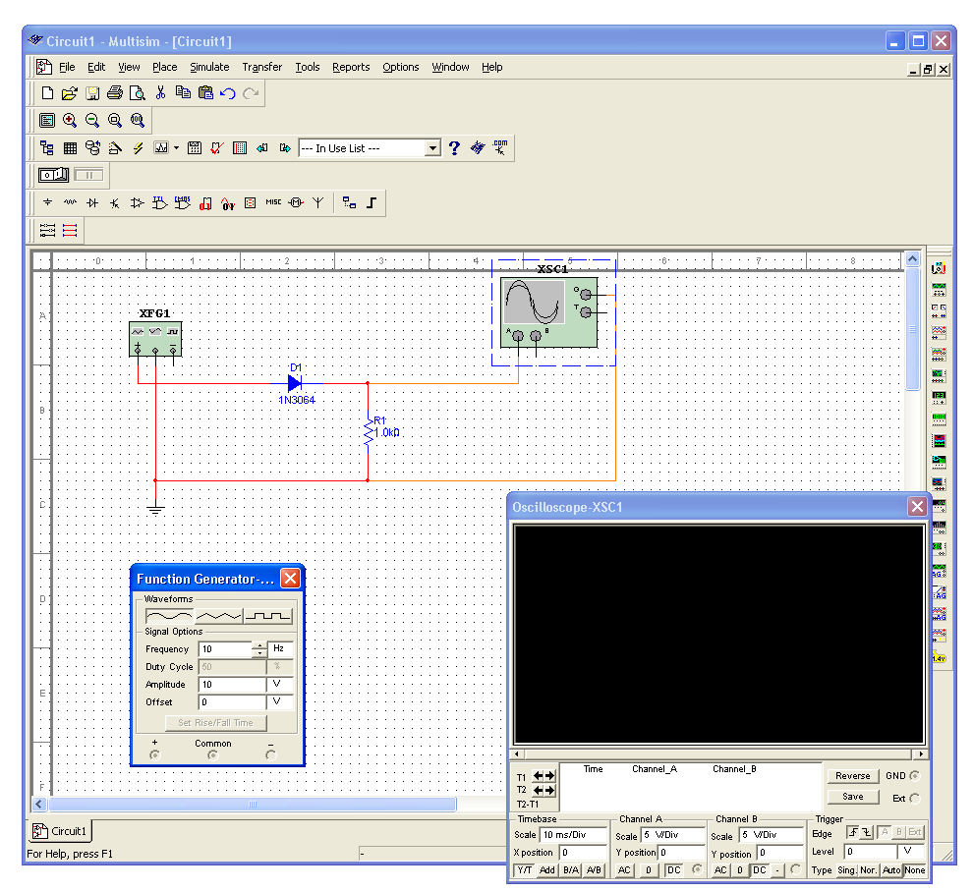
The box on the left is a function generator (found on the right, second from the top). Set its frequency to 10Hz. It will serve as an alternating voltage supply. The box with the sine wave is an oscilloscope (found on the right, fourth from the top). Think of the oscilloscope as a time-dependent voltmeter.

First build the circuit above without the diode. Run a simulation and place a copy of the expanded oscilloscope screen below. Then insert the diode into the circuit and repeat.

Finally build the circuit below, simulate it, and place a copy of its oscilloscope screen below. This circuit is known as a full-wave bridge rectifier. Explain the path taken by the current when the voltage is positive and when it is negative. (Draw a picture twice, indicate on the first the path taken by the current when the voltage at + is positive; indicate on the second the path taken by the current when the voltage at + is negative.)

Part 4. Diode clamps.

Simulate the circuit shown below. Set the amplitude on the signal generator to 5 V and examine the output on the oscilloscope. Then raise the amplitude on the signal generator to 10 V and repeat. What is the effect? Change to the triangular and square waves. Is the effect similar? Paste the resulting oscilloscope screens in your report.

Explain what is happening in this circuit. You may wish to construct a DC version of the circuit shown below and vary the battery that replaced the signal generator from volatges below 5 V to voltages over 5 V.
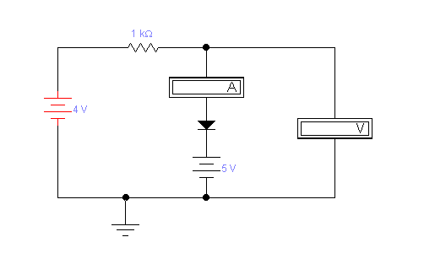
Such a circuit element is called a “diode clamp”; it can be added to a signal that is entering an integrated circuit (digital circuit). What role might a diode clamp play in a computer?

What does the following circuit do?

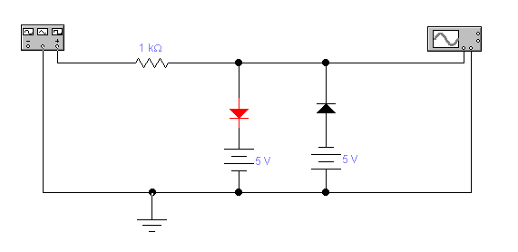

Part 5. Laser printing

Describe the stages of laser printing. What is the role of the laser? Where do the photoconductors come in? Why is the paper warm when it comes out? Sometimes when there’s a paper jam, the print out is very easily smudged; explain what happens in such a case.

